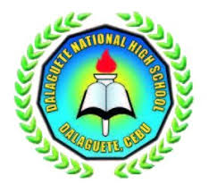

TEACHER

**RULLY B. GLABOG**

**TECHNOLOGY & LIVELIHOOD**

**EDUCATION**

**DAILY LESSON PLAN**

Dalaguete, Cebu

**DALAGUETE NATIONAL HIGH SCHOOL**